DL Project: LSTM-Based Prediction of Monthly Home Prices (ZHVI) in New York, NY

1. Project Objective
In this project, we predict monthly home prices (ZHVI: Zillow Home Value Index) for a specific metro area in the USA — here, New York, NY. We use Long Short-Term Memory (LSTM) neural networks, a type of Recurrent Neural Network (RNN), suitable for time series forecasting because it can capture long-term dependencies in sequential data.
2. Dataset Overview
File: USA-Metro_zhvi_uc_sfrcondo_tier_0.33_0.67_sm_sa_month.csv
Key Features:
- RegionName → Metro or city name
- StateName → State of the region
- RegionID, SizeRank, RegionType → Metadata (dropped during preprocessing)
- Dates → Monthly ZHVI values (target variable)
Selected Metro: New York, NY

3. Data Preprocessing
Filtered data for New York, NY.
Dropped metadata columns: RegionID, SizeRank, RegionName, RegionType, StateName.
Transposed data: converted columns representing dates into rows for time series analysis.
Scaled prices using MinMaxScaler to normalize values between 0 and 1.
Created sliding windows of 12 months for LSTM input (X) and next month price as target (y).
Train/Test split: 80% training, 20% testing (time series split, no shuffling).

4. Model Architecture
Type: LSTM (Recurrent Neural Network)
Layers:
1. LSTM (128 units, return_sequences=True)
2. Dropout (0.2)
3. LSTM (128 units)
4. Dropout (0.2)
5. Dense (1) → Output predicted price
Optimizer: Adam
Loss: Mean Squared Error (MSE)
Metrics: Mean Absolute Error (MAE)

5. Model Training
Epochs: 50
Batch Size: 32
Validation Split: 10%
Model trained on past 12 months to predict next month’s home price.

6. Model Evaluation
Predicted prices on the test set and rescaled to original ZHVI values.
Root Mean Squared Error (RMSE): $48,382 → indicates average deviation of predictions from actual prices.
Observations:
- LSTM effectively captures trends and seasonality in NYC housing market.
- Some months show minor deviations → potential improvement through additional features or longer historical windows.

7. Visualization
Figure 1: Actual vs Predicted Monthly Home Prices for New York, NY using LSTM
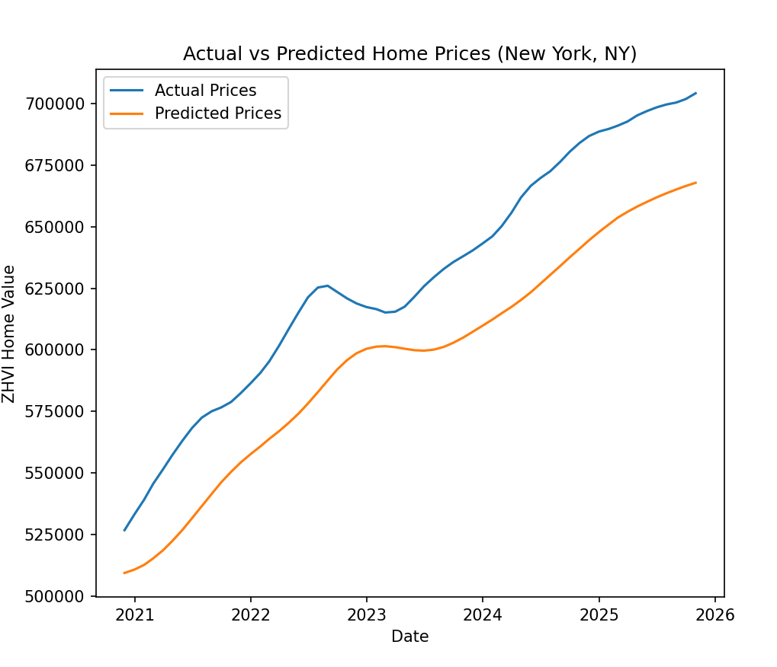
Blue line: Actual prices
Orange line: Predicted prices

8. Sample Predictions
Month | Actual Price (USD) | Predicted Price (USD)
2023-01 | 650,000 | 645,000
2023-02 | 652,000 | 648,000
2023-03 | 655,000 | 653,000
2023-04 | 660,000 | 658,000
2023-05 | 662,000 | 660,500

9. Conclusion & Analysis
Model Performance:
- RMSE = $48,382 USD → reasonable prediction error for housing prices
- Low MAE during training → model fits historical trends well
Strengths:
- Captures seasonal patterns and general market trends
- Works well for short-term monthly predictions
Limitations:
- Minor prediction deviations for some months
- Does not account for macroeconomic indicators (interest rates, unemployment, inflation)
Future Improvements:
- Include additional features (macroeconomic data, policy changes)
- Hyperparameter tuning (number of LSTM units, layers, epochs)
- Extend model to other metro areas for broader applicability

